CASE 1: 3 players, $t = 100$

g0, Total Embarrassment = 10576

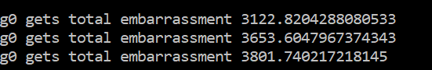

g3, Total Embarrassment = 10421

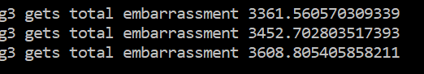

Player 2 and 3 have an embarrassment score which is lesser than their initial one. However, the performance of Player 1 deteriorates

CASE 2: 3 players, $t=500$

g0, Total Embarrassment = 10308

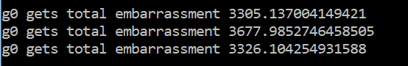

g3, Total Embarrassment = 10597

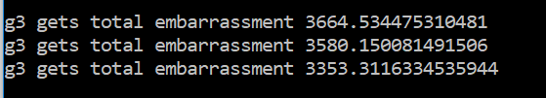

Player 2 and 3 have an embarrassment score which is lesser than their initial one. However, the performance of Player 1 deteriorates

CASE 3: 3 players, $t=1000$

g0, Total Embarrassment = 10789

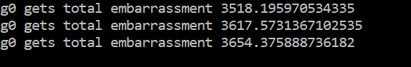

g3, Total Embarrassment = 10619

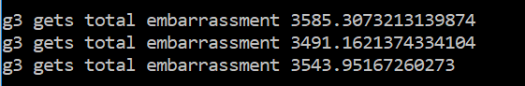

All players have improved performance